Lawyers who win (C) 2025

What Matters: Social 2025

Save the date
----------------------------------------------------------------------------------------------------------------
We believe that a little more in-person connection matters. Let’s start the new year right by eliminating at least one video conference and ensuring no one is on mute.
Join us in March 2025 for What Matters Social in your city. Register your interest

Invite PDF
----------------------------------------------------------------------------------------------------------------
You’re Invited
We’re starting the new year with four social events, eliminating at least one video conference and ensuring no one was on mute. Join us at this What Matters Social to celebrate our community and collaboration.
Please RSVP by 7 February 2024.
Drinks & Canapés from 5:30pm. Places will be limited.
Brisbane – Club Felix
Thursday, 27 Feb 2025, 5:30–8:30pm
Melbourne – Yakimono
Thursday, 6 Mar 2025, 5:30–8:30pm
Sydney – Panorama Bar
Thursday, 20 Mar 2025, 5:30–8:30pm
Perth – HQ Bar
Thursday, 3 Apr 2025, 5:30–8:30pm

Mailflow Rules
----------------------------------------------------------------------------------------------------------------
[subject]
Join us in celebrating our community with your peers at a great venue in your city 👋
Reminder: See you at What Matters Social: Thursday, 27 Feb. from 5:30pm
Reminder: See you at What Matters Social: Thursday, 6 Mar. from 5:30pm
Reminder: See you at What Matters Social: Thursday, 20 Mar. from 5:30pm
Reminder: See you at What Matters Social: Thursday, 3 Apr. from 5:30pm
Thanks for playing – Sky Discovery

Invite Email
----------------------------------------------------------------------------------------------------------------
[subject]
Join us in celebrating our community with your peers at a great venue in your city 👋
[preview]
You could win with Sky Discovery in any number of ways!*
[copy]
YOU’RE INVITED
Join your community and peers for drinks and canapés 🥂
As we champion technical solutions, we are mindful of the impact technology use and remote work can have on real human interaction. We’re always exploring ways to ensure that our team and client-partner network can engage with each other meaningfully. We believe that a little more in-person connection is what matters.
Join us to celebrate our community and collaboration at a great venue in your city. Let’s start the year right, with one less video conference and no one on mute.
Please RSVP by 7 February 2024.
Drinks & Canapés from 5:30pm. Places will be limited.
Brisbane – Club Felix
Thursday, 27 Feb 2025, 5:30–8:30pm
Melbourne – Yakimono
Thursday, 6 Mar 2025, 5:30–8:30pm
Sydney – Panorama Bar
Thursday, 20 Mar 2025, 5:30–8:30pm
Perth – HQ Bar
Thursday, 3 Apr 2025, 5:30–8:30pm

[link] /what-matters

Blocker Gameplay Notification Email
----------------------------------------------------------------------------------------------------------------
[subject]
Thanks for playing the game.
[preview]
You could win with Sky Discovery in any number of ways!*
[copy]

Thanks for playing the game.
You could win with Sky Discovery in any number of ways!*
At Sky Discovery, everything we do is about making life easier for lawyers.
We’re all in the game. To play it better, you need to clear those blockers and your mind. So, we made a game not only for some escapism but also for the metaphors.
*Lawyers who work with Sky Discovery are already winning. Let us count the ways. From (1) specialist legal and eDiscovery support to (2) custom Relativity features and AI capabilities, (3) weekends away, (4) dinners on the town, and (5) spa sessions for your health. Terms & Conditions apply.

Thanks for being part of our community.
Whether via your inbox or in person, What Matters aims to put the critical pieces together for lawyers and their teams.
[link]
Learn more

Competition Winners Email
----------------------------------------------------------------------------------------------------------------
[subject]
You are a lawyer who won!
[body]
Hi <Name>

Thanks for playing the game. You won!
We’re all in the game. To play it better, you need to clear those blockers and your mind. So, we made a game not only for some escapism but also for the metaphors. We know that lawyers can be competitive, but the response to our remake of this retro classic has been brilliant and guess what?
You’ve won one of three options: (1) A weekend away with Unyoked, (2) a $500 dining experience at (a restaurant of your choice (or <Name>), or (3) a $500 voucher for a day spa of your choice (or <Name>).
Once you confirm your preference, we’ll arrange your voucher.

Thanks for being part of our community.
Whether via your inbox or in person, What Matters aims to put the critical pieces together for lawyers and their teams. Team Sky Discovery thanks you for joining us and your peers to celebrate our community and collaborations.
Why we do this:
- Everything we do is about making life easier for lawyers.
- We simply want you to think of us whenever you need an eDiscovery specialist on the case.
- That’s why we decided to do something fun and unexpected, like giveaways (for your health).
- We know what you and your inboxes are dealing with, so we won’t add to it unnecessarily.
- We’ll never send more than six (6) emails worth reading each year.
- Every email contains new ways for lawyers and their teams to win, so we hope you’ll stay.
- Our last email explored burnout in Australia's legal industry.
- Whatever happens, you know where to find us.

You can win with Sky Discovery in any number of ways!*
* Lawyers working with Sky Discovery are already winning. In addition to our specialised legal and eDiscovery support, as well as custom Relativity features and AI capabilities, we also recognise that one prize isn’t nearly enough. So… we’re doing it again with new ways to win throughout the year. So, stay connected, and we’ll let you know so you can enter again!
[link]
Learn more

Competition Winners Email – Voucher
----------------------------------------------------------------------------------------------------------------
[subject]
You are a lawyer who won!
[body]
Hi <Name>
We’re excited for you (and a little envious!).
Please find attached your voucher for a weekend away with Unyoked, a dining experience at <Name>, a spa experience at <Name> for your health.
We’d love for you to save and share the image below on LinkedIn and mention us!
[image]
Assets

Competition Entrants Email
----------------------------------------------------------------------------------------------------------------
[subject]
Lawyers that win!
[body]
Hi <Name>

Thanks for playing the game.
We’re all in the game. To play it better, you need to clear those blockers and your mind. So, we made a game not only for some escapism but also for the metaphors. We know that lawyers can be competitive, but the response to our remake of this retro classic has been brilliant.
The winners have been notified, and if you weren’t the one this time, that’s okay.

You can win with Sky Discovery in any number of ways!*
*Lawyers working with Sky Discovery are already winning. In addition to our specialised legal and eDiscovery support, as well as custom Relativity features and AI capabilities, we also recognise that one prize isn’t nearly enough for all the hard-working lawyers out there. So… we’re doing it again with new ways to win throughout the year. So, stay connected, and we’ll let you know so you can enter again!

Thanks for being part of our community.
Whether via your inbox or in person, What Matters aims to put the critical pieces together for lawyers and their teams. Team Sky Discovery thanks you for joining us and your peers to celebrate our community and collaborations.
Why we do this:
- Everything we do is about making life easier for lawyers.
- We simply want you to think of us whenever you need an eDiscovery specialist on the case.
- That’s why we decided to do something fun and unexpected, like giveaways (for your health).
- We know what you and your inboxes are dealing with, so we won’t add to it unnecessarily.
- We’ll never send more than six (6) emails worth reading each year.
- Every email contains new ways for lawyers and their teams to win, so we hope you’ll stay.
- Our last email explored burnout in Australia's legal industry.
- Whatever happens, you know where to find us.

[link]
Learn more

Social Caption – Post Event
----------------------------------------------------------------------------------------------------------------
[caption]
We decided to start the year with four social events, eliminating at least one video conference and ensuring no one was on mute. As we champion technical solutions, we are mindful of the impact technology use and remote work can have.
Everything we do is about making life easier for lawyers and their teams. We know what lawyers and their teams are dealing with, and we believe you deserve some downtime now and then. So, in addition to a great catch-up with peers and our community, a lucky few who joined us at each of our recent events were also gifted a well-deserved prize of their choice from (1) a weekend away with Unyoked, (2) a dining experience or (3) a day spa session.
We’re all in the game. To play it better, you need to clear those blockers and your mind. So, we made a game not only for some escapism but also for the metaphors. We know that lawyers can be competitive, but the response to our latest remake of this retro classic has been brilliant.
Thanks to those who joined us at What Matters Social in Melbourne, Sydney, and Brisbane, Perth and for playing our remake of Blocker; well done!
The winners have been notified, and if you weren’t the one this time, that’s okay.

You can win with Sky Discovery in any number of ways!*
*Lawyers working with Sky Discovery are already winning. In addition to our specialised legal and eDiscovery support, custom Relativity features, and AI capabilities, we’re always looking for more ways for lawyers to win. As it turns out, lawyers who work with Sky Discovery are in it to win it, so stay tuned for your next opportunity. There will be more ways to win soon!
If you missed out on the win or want to join us again, please feel free to register your interest for the next one
[link]
[images] TBC

What Matters Social Terms
----------------------------------------------------------------------------------------------------------------

Terms
- The Promoter is: Sky Discovery Pty Ltd (ACN 609 289 214) of registered office address: Level 29, Chifley Tower, 2 Chifley Square Sydney NSW 2000.
- Employees of the Promoter or their family members or anyone else connected in any way with the competition or helping to set up the competition shall not be permitted to enter the competition.
- To enter the competition, an entrant must provide the requested details on the Promoter’s website and submit the completed entry form.
- Competition opens on:
  - Queensland – 27 February 2025 at 5pm
  - Victoria – 6 March 2025 at 5pm (AEDT);
  - New South Wales – 20 March 2025 at 5pm (AEDT);
  - Western Australia – 3 April 2025 at 5pm.
- Closing dates for entry will be:
  - Queensland – 6 March 2025 at 5pm
  - Victoria – 13 March 2025 at 5pm (AEDT);
  - New South Wales – 27 March 2025 at 5pm (AEDT);
  - Western Australia – 10 April 2025 at 5pm.
- After this date the no further entries to the competition will be permitted.
- No responsibility can be accepted for entries not received for whatever reason.
- The rules of the competition and the prize for each winner are as follows:
- Entrants must be over 18 to enter.
- Entrants must be Permanent Residents of Australia.
- Each entrant can enter the draw only once.
- The entrant must be employed by a legal firm in Australia.
- The Promoter reserves the right to cancel or amend the competition and these terms and conditions without notice in the event of a catastrophe, war, civil or military disturbance, act of God or any actual or anticipated breach of any applicable law or regulation or any other event outside of the Promoter’s control. The Promoter will notify entrants of any changes to the competition as soon as possible.
- The Promoter is not responsible for inaccurate prize details supplied to any entrant by any third party connected with this competition.
- No cash alternative to the prizes will be offered. The prizes are not transferable. Prizes are subject to availability, and we reserve the right to substitute any prize with another of equivalent value without giving notice.
- This is a game of chance; skill plays no part in determining the winner.
- The Prize 3 x $500 Vouchers (1 per winner, per event) for 1 x weekend away, 1 x day spa treatment, 1 x dinner.
- Playing the game on this website and submitting the form will 6x your entries.
- Winners will be drawn at random on:
  - Queensland – 12 March 2025 at 5 pm
  - Victoria – 20 March 2025 at 5pm (AEDT);
  - New South Wales – 6 April 2025 at 5pm (AEDT);
  - Western Australia – 17 April 2025 at 5pm.
- The winner will be the first valid entry drawn, which complies with the rules for entry at item 7.
- The winner will be notified by email within 28 days of the closing date. If the winner cannot be contacted or do not claim the prize within 14 days of notification, the Promoter reserves the right to withdraw the prize from the winner and pick a replacement winner.
- The Promoter will notify the winner when and where the prize can be collected.
- The Promoter’s decision in respect of all matters to do with the competition will be final and no correspondence will be entered into.
- By entering this competition, an entrant is indicating his/her acceptance and agreement to be bound by these terms and conditions.
- The competition and these terms and conditions will be governed by Australian law and any disputes will be subject to the exclusive jurisdiction of the courts of Australia.
- The winner agrees to the use of his/her name and image in any publicity material. Any personal data relating to the winner, or any other entrants will be used solely in accordance with current Australian data protection legislation and will not be disclosed to a third party without the entrant’s prior consent.
- The winner’s name will be shared via email.
- This promotion is in no way sponsored, endorsed or administered by, or associated with, LinkedIn, X, Meta, or any other Social Network. You are providing your information to the Promoter and not to any other party.

Last updated 27.02.25

Spare
There was a time when lawyers could focus more on the law. Time flies, and so does technology.

Nowadays, nearly everything is discoverable. Innovation remains a priority for lawyers, but collecting and organising data is often complex and inefficient. The specialised area of discovery demands swift, defensible execution. In many ways, it is not actually lawyering.

Putting the critical pieces together for lawyers
Since 2016, our mission has been to uncover what matters for lawyers and their teams. The volumes of discoverable data will keep growing while deadlines keep shrinking. Every day, we see how lawyers who partner with us across Australia and the UK have more time to focus on the law.
If you need practical solutions for changing priorities from eDiscovery experts who work when you do, we are here to help with the next steps in your process.

Helpful resources
Using eDiscovery as part of your pitch to win work | ↗
What makes a good eDiscovery partner | ↗
Finding needles in the data haystack | ↗

Wrap-up Post
----------------------------------------------------------------------------------------------------------------
Happy Friday! On behalf of the entire @Sky Discovery team, thanks for making time for yourself. For the last few months, we asked the lawyers of Australia to pause for a moment, have some fun and maybe win a weekend away, for their health. We were thrilled by the overwhelming response.
The winners have been notified, and if it wasn’t you this time, that ok… we’re doing it again with new ways to win next year, so stay connected, and we’ll let you know!
Why we do this:
- Everything we do is about making life easier for lawyers.
- We simply want you to think of us whenever you need an eDiscovery specialist on the case.
- That’s why we decided to do something fun and unexpected, like giving away a weekend (for your health).
- We know what you and your inboxes are dealing with, so we won’t add to it unnecessarily.
- We’ll never send more than six (6) emails worth reading each year.
- Every email contains new ways for lawyers and their teams to win, so we hope you’ll stay.
- Our last email explored burnout in Australia's legal industry.
- Whatever happens, you know where to find us.

If you have any questions for us, feel free to reach out via solutions@skydiscovery.com.au
PS: We also remade a classic game 🐍 not only for some fun but also for the metaphors. We know lawyers can be competitive, but we can't believe how high some of the scores are! https://skydiscovery.com.au/lawyers-that-win-with-good-ediscovery/play

Before you go, there is another way!
Unyoked is offering 20% off employee gift voucher bundles + every purchase goes in the draw to win an Unyoked offsite for 4 people! Offer ends Dec 25th. Organise a proper reset for the team (in nature) ahead of 2025: https://store.unyoked.co/collections/corporate-gifts-au
Enjoy the weekend! Maybe go for a nature walk with AllTrails 🦅

What Matters Social (Webpage old version)
What Matters aims to put some of the critical pieces together for lawyers. As champions of technical solutions, we are mindful of how technology use impacts humans, interactions and the way we work.
What Matters In-person We believe that a little more in-person connection is matters. By subscribing below, you'll also hear about the next event to connect with our community at a great venue in your city. It's all about one less video conference and no one on mute.
What Matters Inbox Our bi-monthly newsletter provides helpful insights and ways to win for lawyers and their teams. We believe it’s one email worth reading — and we’ll never send more than six (6) per year. We've explored Working from home, burnout 🥵 and artificial intelligence 🤖. Talking of ways to win, you can also go into the draw to win a weekend away.
Please subscribe to hear about What Matters via the form below ↓ ↓ ↓

At Sky Discovery, everything we do is about making life easier for lawyers.
We’re all in the game. To play it better, you need to clear those blockers and your mind. So, we made a game not only for some escapism but also for the metaphors.
Clear some units and win with Sky Discovery in any number of ways!*
At Sky Discovery, everything we do is about making life easier for lawyers.
We’re all playing the game. To play the game better, you need to clear those blockers. So, we made a game not only for some fun but also for the metaphors.
Clear some units, get some time back and/or some downtime with Sky Discovery in a number of ways*

At Sky Discovery, everything we do is about making life easier for lawyers. We’re all playing the game. To play the game better, you need to clear those blockers and your mind. So, we made a game not only for some fun but also for the metaphors.
Clear some units and win with Sky Discovery in a number of ways*

At Sky Discovery, everything we do is about making life easier for lawyers. We’re all playing the game. To play the game better, you need to clear those blockers and your mind. So, we made a game not only for some fun but also for the metaphors.
Clear some units and win with Sky Discovery in a number of ways*

*Lawyers who work with Sky Discovery are already winning. Let us count the ways. From (1) specialist legal and eDiscovery support to (2) custom Relativity features and AI capabilities, (3) weekends away, (4) dinners on the town, and (5) spa days for your health. Entries close at 11pm on 23.09.25

“We understand that eDiscovery often only comes to mind when it’s needed (yesterday), but when it does, we want to be at the front. Everything we do is about making life easier for lawyers and honestly, we just want you to think of us whenever you need an eDiscovery specialist on the case. That’s why they decided to do something fun, unexpected and hopefully memorable. Lawyers who work with Sky Discovery are already winning largely because we know what they’re dealing with. As champions of technology-assisted work practices, we also see the impact of increased technology use and remote working on our ability to unwind.”

We hope you win! All you have to do is play the game wisely.

We know what lawyers are dealing with, and you deserve some time back and/or downtime now and then.

Everything we do is about making life easier for lawyers. That’s why your eDiscovery is better with us.

Our global team of lawyers, eDiscovery experts, technicians, and innovators make our market-leading work possible. We offer around-the-clock specialist support alongside market-leading custom tools and workflows designed to enhance RelativityOne and Relativity Server.
In partnership with our clients, Sky Discovery supports disputes, regulatory responses, and investigations in Australia and the UK. We truly understand discovery and disclosure challenges and know how to make a positive difference. AI or otherwise, we always find practical solutions to make lawyers’ lives easier.
Meet our team ›

“Sky Discovery is a true trailblazer in its field, and it should be commended for its hard work and dedication to providing quality services. I know that the team at Sky work hard and genuinely cares about fostering relationships with the people behind the business.”
Senior Associate Large National Class Action Firm

Matter data sorted, and your team supported; this is what to expect.
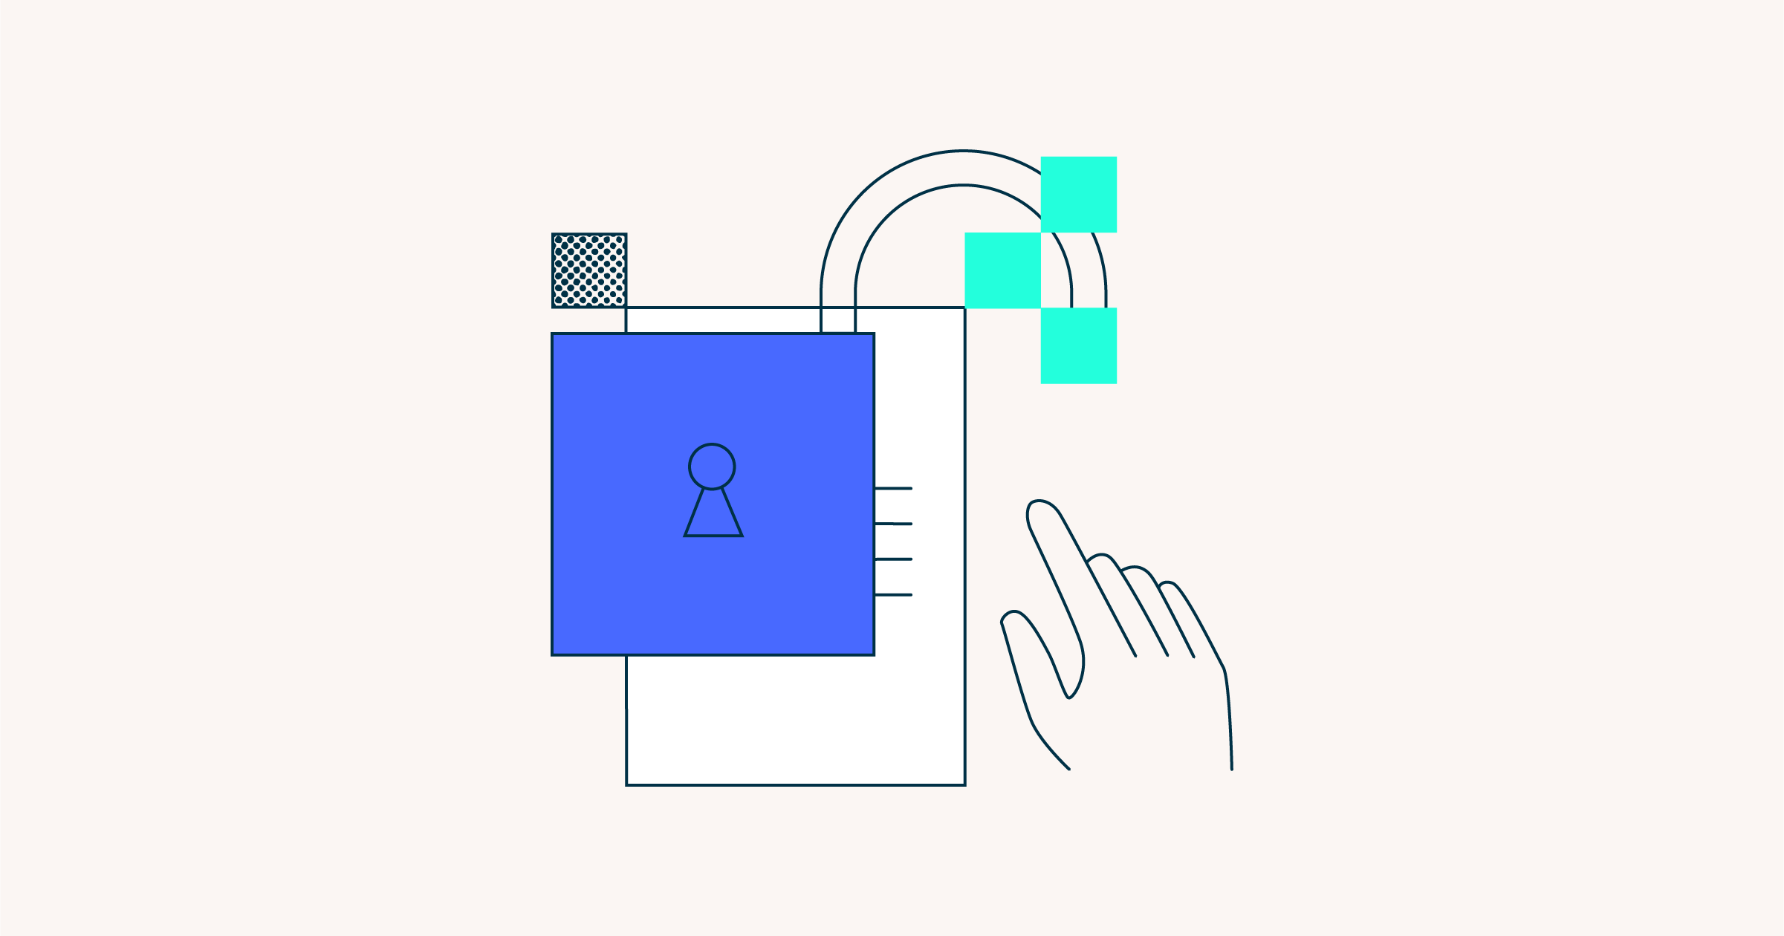

Security first
You and your client need peace of mind regarding critical information security. We are ISO27001 certified and prioritise best practices for risk management, including our own 24/7 monitoring and regular audits.
What to expect ›

Specialist support
Sky Discovery’s 24/7/365 support means a rapid start with RelativityOne or Relativity Server workspaces, advanced custom workflows, and a responsive team with deep legal and eDiscovery experience.
How we help ›

Solutions always
Our developers, database administrators, and subject matter experts resolve new technical challenges daily. AI or otherwise, we always find practical, accurate and defensible solutions to make lawyers’ lives easier.
Our solutions ›

“Based on my contrasting experience with similar competitors, I believe Sky Discovery provides market-leading service and value.”
Principal Specialist Construction Law Firm



We know:
- Our clients deal with diverse stakeholders, so we provide options and recommendations for custom technical solutions that suit the specifics of their matter.
- Most matters have urgent deadlines and multiple moving parts, so we developed management structures that prioritise responsiveness, provide clarity, and adapt to change.
- Lawyers often work beyond 9 to 5 and across time zones, so we shaped a global team of experts to work when our clients do.
- What data types are emerging and problematic, so we design systems and workflows that enhance that data and make it work for our clients.
- eDiscovery can be complex, so we created an open reference library that makes understanding and practising eDiscovery accessible not just for our clients but the entire legal community.
- Our clients (and their clients) value information security, so we maintain a robust and rigorous Information Security Management System that we regularly test and enhance.
- Our clients require impeccable quality, so we initiated a quality management committee and innovation team to continually review our processes and identify new solutions for improving eDiscovery.

“Since its inception, I have worked closely with Sky Discovery and am consistently impressed by their responsiveness, adaptability, and initiative.”
Partner Large International Law Firm

Accurate work product in your hands sooner.
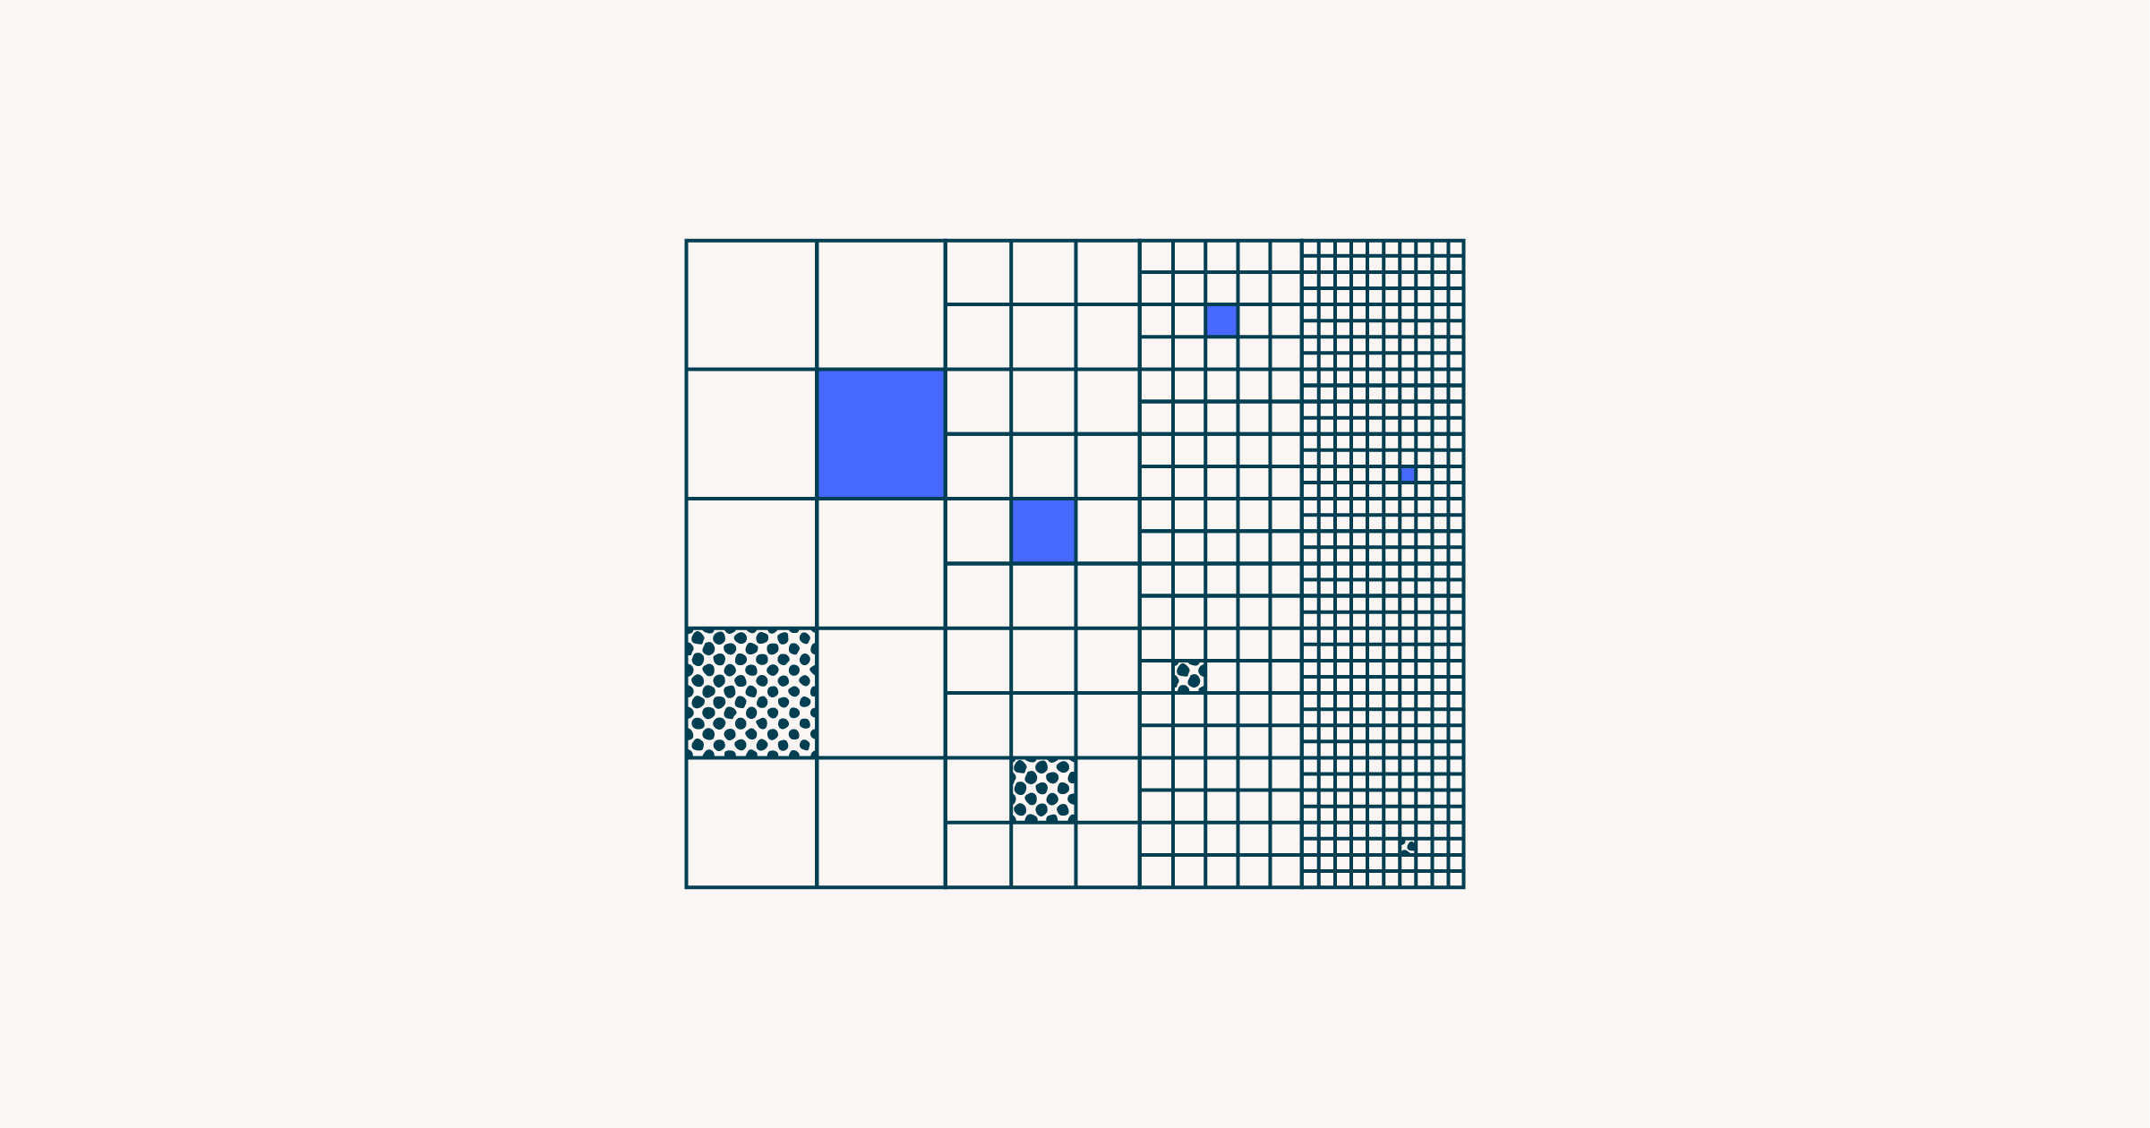
Our partners benefit from our approach to continuous optimisation and improvement for scale and speed. Our custom features allow us to get more done without charging you more. When you work with Sky Discovery, you’re not paying for software; you’re leveraging innovation and specialist support.

Solutions and impact

Collecting data  from Microsoft  365 quickly and defensibly ↗ |  | Leveraging continuous active learning in large scale document review ↗ |  | Migrating an active eDiscovery project from another provider ↗
Dispute, Collect, Regulatory, Investigation, Locate |  | Dispute, Analyse, Review, Sky Solution |  | Dispute, Regulatory, Investigation, Process

Client success ›

We put the critical pieces together for lawyers; this is how we help.



eDiscovery as a competitive advantage
We frequently help legal teams transition into integrated partnerships that meet their data collection, analysis, management, and review needs. Sky Discovery collaborates with clients beyond individual matters, progressively implementing solutions that serve as competitive advantages for legal teams.

Resources for lawyers
We are committed to R&D and best practices to empower our partners with assurance. Acknowledging the complexities of eDiscovery, we have created a comprehensive index of publicly accessible resources, which is available not only to our clients but also to the broader legal community.
Resources index ›

Scoping and proposals simplified
Collaborating with your eDiscovery partner as soon as possible is key. Use our scoping tool to highlight challenges and prompt timely solutions. The more details you share, the more accurate our recommendations and estimates will be. If some information is not yet available, that’s perfectly acceptable.
Start scoping ›
Practice directions by jurisdiction  Reference our up-to-date index of all Australian and UK eDiscovery practice directions › | 

Do more with Sky Discovery technology.
Every day, our developers, database administrators, and subject matter experts find practical, accurate, and defensible solutions to new challenges. Our client partners have access to our growing AI capabilities and the same advanced custom integrations across RelativityOne and Relativity Server.

Our growing AI capabilities

Leverage AI on your next matter. Book a free workshop ›

Advanced custom integrations

We’re ready to assist you with the next steps in your matter process.

We understand that eDiscovery often only comes to mind when it’s needed (yesterday), but when it does, we want to be at the front. Everything we do is about making life easier for lawyers, and honestly, we just want you to think of us whenever you need an eDiscovery specialist on the case in Australia or the UK.

While our technology is critical, our people set us apart. Let’s meet so you can see for yourself.

Book a presentation, a workshop, or just a quick coffee ☕️

“Since its inception, I have worked closely with Sky Discovery and am consistently impressed by their responsiveness, adaptability, and initiative.”
Partner Large International Law Firm

Helpful resources
Limiting the risks of data self-collection | ↗
Drafting effective exchange protocols | ↗
Reviewing with AI-powered workflows | ↗

